**Creating Microservices for account and loan**

**Account**

**AccountController.java**

package com.cognizant.account.controller;

import org.springframework.web.bind.annotation.*;

import java.util.Map;

@RestController

@RequestMapping("/accounts")

public class AccountController {

@GetMapping("/{number}")

public Map<String, Object> getAccountDetails(@PathVariable String number) {

return Map.of(

"number", number,

"type", "savings",

"balance", 234343

);

}

}

**Application**

package com.cognizant.account;

import org.springframework.boot.SpringApplication;

import org.springframework.boot.autoconfigure.SpringBootApplication;

@SpringBootApplication

public class AccountApplication {

public static void main(String[] args) {

SpringApplication.run(AccountApplication.class, args);

}

}

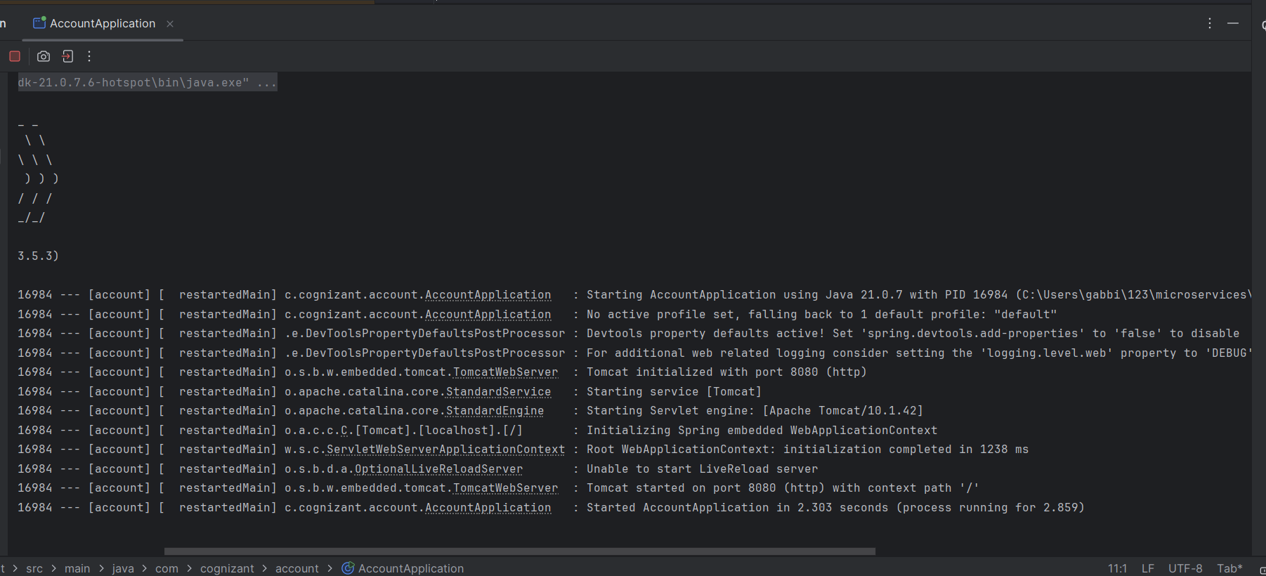

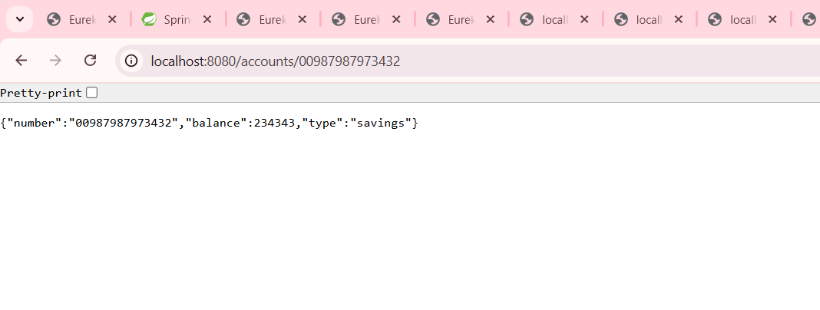

**Loan Microservice**

**LoanController**

package com.cognizant.loan.controller;

import org.springframework.web.bind.annotation.*;

import java.util.Map;

@RestController

@RequestMapping("/loans")

public class LoanController {

@GetMapping("/{number}")

public Map<String, Object> getLoanDetails(@PathVariable String number) {

return Map.of(

"number", number,

"type", "car",

"loan", 400000,

"emi", 3258,

"tenure", 18

);

}

}

**Application**

package com.cognizant.loan;

import org.springframework.boot.SpringApplication;

import org.springframework.boot.autoconfigure.SpringBootApplication;

@SpringBootApplication

public class LoanApplication {

public static void main(String[] args) {

SpringApplication.run(LoanApplication.class, args);

}

}

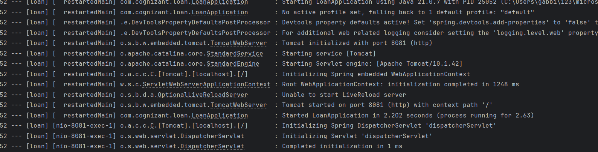

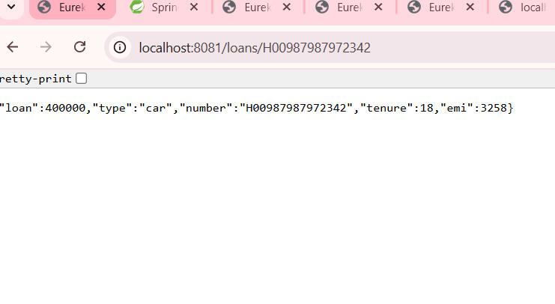

**Create Eureka Discovery Server and register microservices**

**Application**

package com.cognizant.eureka_discovery_server;

import org.springframework.boot.SpringApplication;

import org.springframework.boot.autoconfigure.SpringBootApplication;

import org.springframework.cloud.netflix.eureka.server.EnableEurekaServer;

@SpringBootApplication

@EnableEurekaServer

public class EurekaDiscoveryServerApplication {

public static void main(String[] args) {

SpringApplication.run(EurekaDiscoveryServerApplication.class, args);

}

}

**Application.properties**

spring.application.name=eureka-discovery-server

server.port=8761

eureka.client.register-with-eureka=false

eureka.client.fetch-registry=false

logging.level.com.netflix.eureka=OFF

logging.level.com.netflix.discovery=OFF

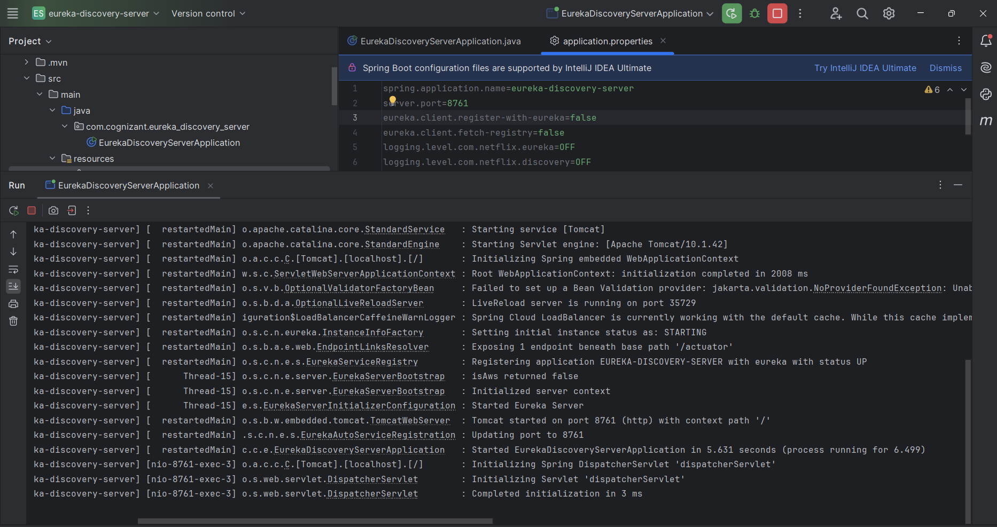

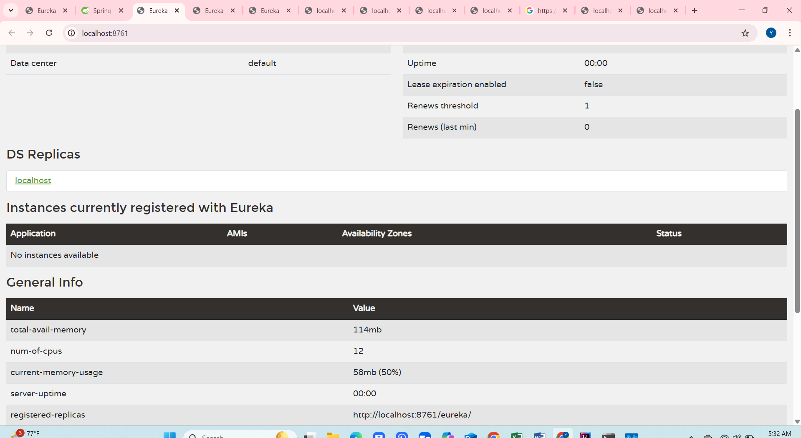

**Account**

package com.cognizant.account1;

import org.springframework.boot.SpringApplication;

import org.springframework.boot.autoconfigure.SpringBootApplication;

import org.springframework.cloud.client.discovery.EnableDiscoveryClient;

@SpringBootApplication

@EnableDiscoveryClient

public class Account1Application {

public static void main(String[] args) {

SpringApplication.run(Account1Application.class, args);

}

}

**Application.properties**

spring.application.name=account1

spring.application.name=account-service

server.port=8081

eureka.client.service-url.defaultZone=http://localhost:8761/eureka

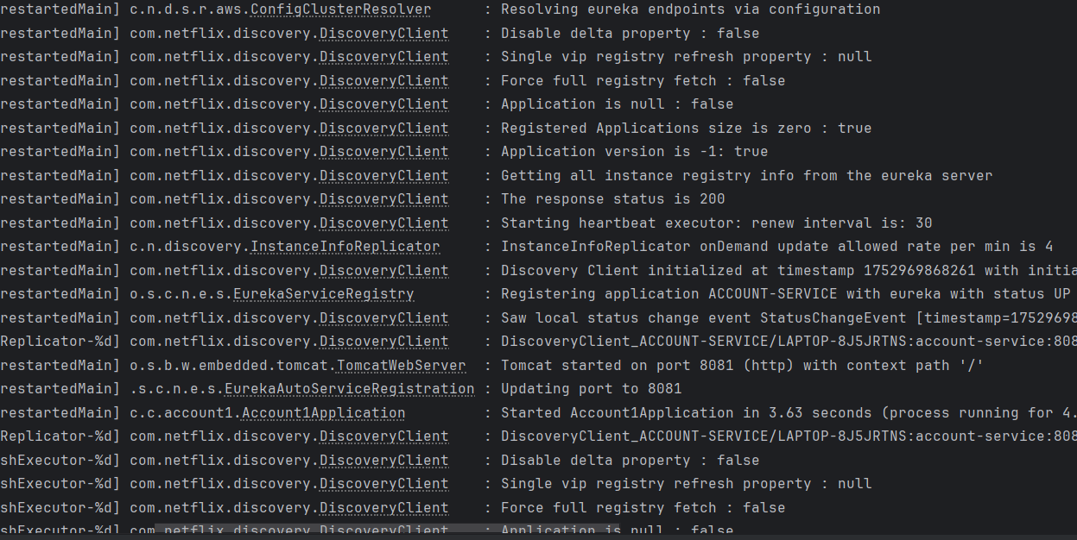

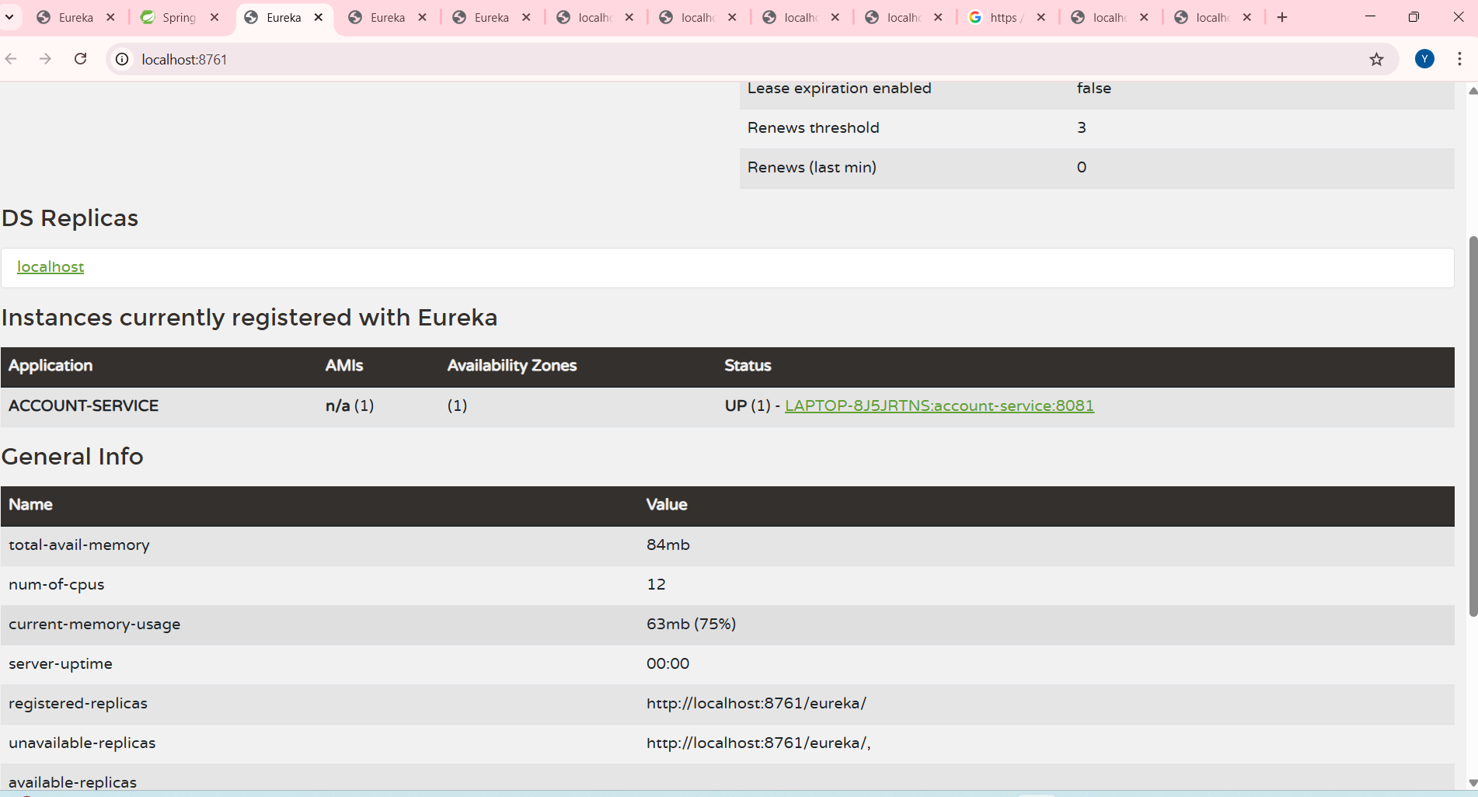

**Loan**

package com.cognizant.loan1;

import org.springframework.boot.SpringApplication;

import org.springframework.boot.autoconfigure.SpringBootApplication;

import org.springframework.cloud.client.discovery.EnableDiscoveryClient;

@SpringBootApplication

@EnableDiscoveryClient

public class Loan1Application {

public static void main(String[] args) {

SpringApplication.run(Loan1Application.class, args);

}

}

**Properties**

spring.application.name=loan1

spring.application.name=loan-service

server.port=8082

eureka.client.service-url.defaultZone=http://localhost:8761/eureka

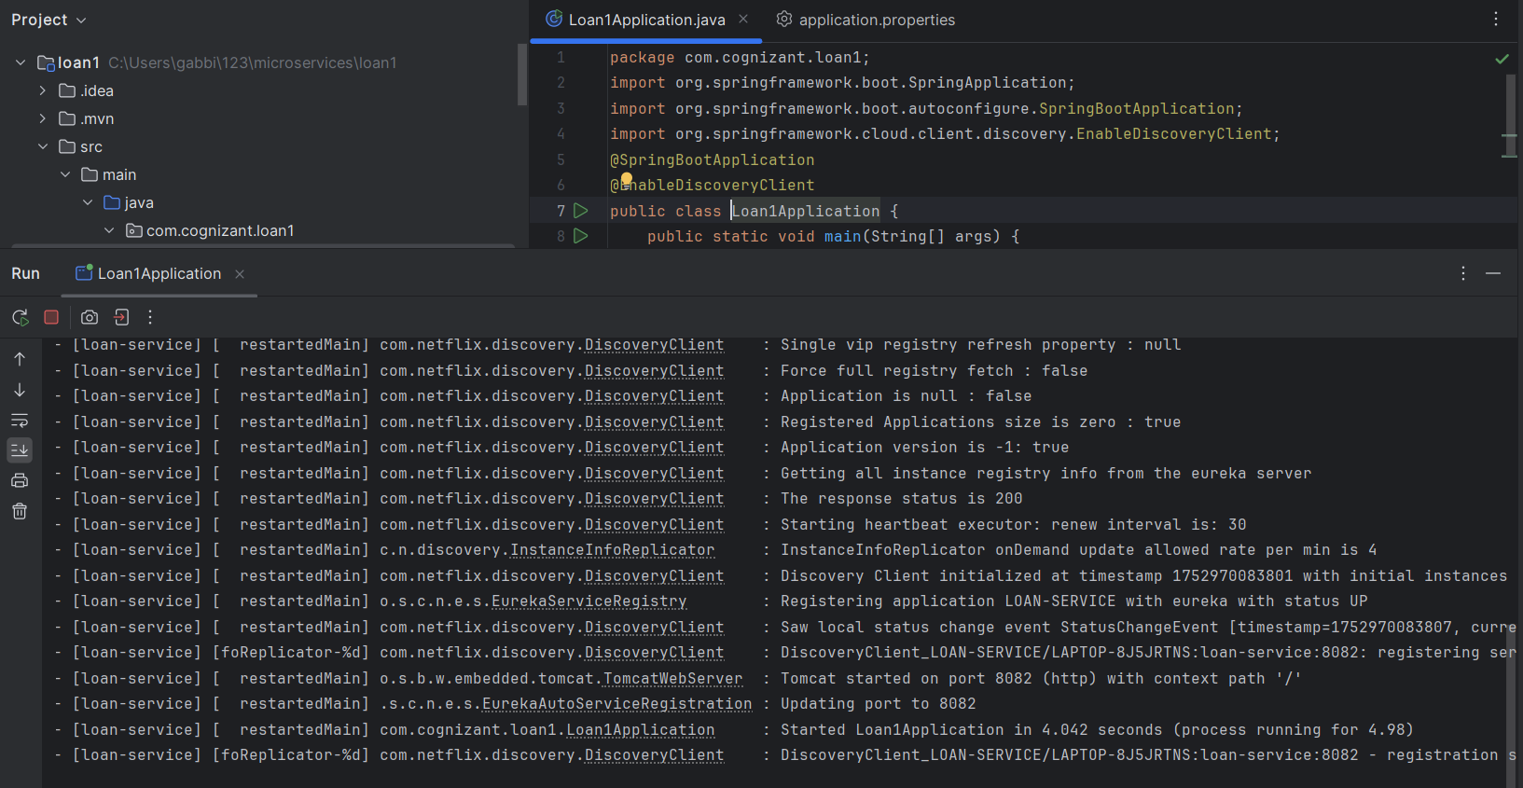

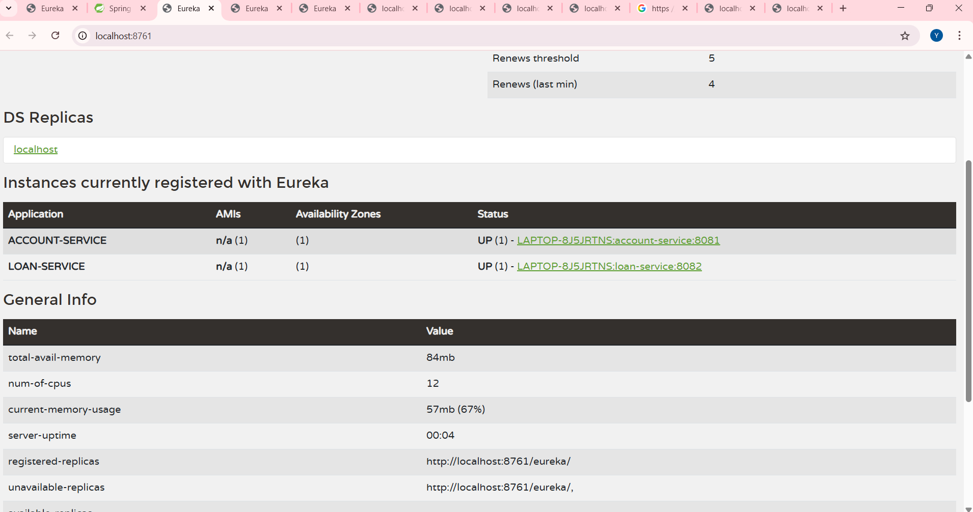

**Create a Spring Cloud API Gateway and call one microservice thru the API gateway. Configure a global filter to log each request targeting the microservice using Spring Cloud API Gateway.**

**Greetservice**

package com.example.greetservice.controller;

import org.springframework.web.bind.annotation.GetMapping;

import org.springframework.web.bind.annotation.RestController;

@RestController

public class GreetController {

@GetMapping("/greet")

public String greet() {

return "Hello World";

}

}

**Properties**

spring.application.name=greet-service

server.port=8090

eureka.client.service-url.defaultZone=http://localhost:8761/eureka

eureka.client.register-with-eureka=true

eureka.client.fetch-registry=true

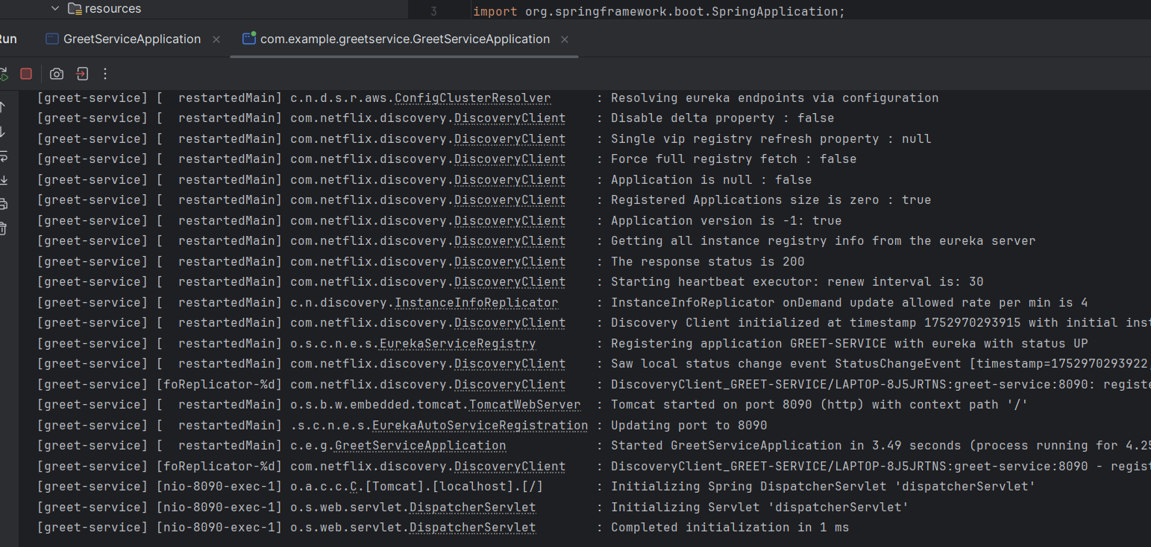

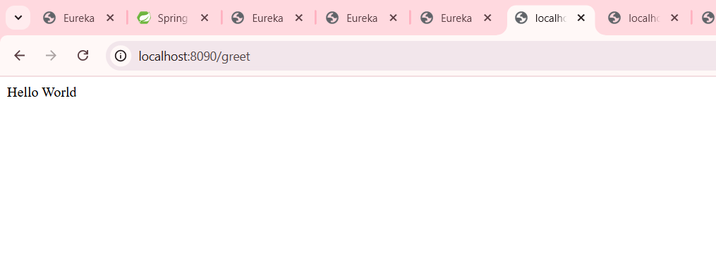

**Eureka-server**

package com.example.eureka_server;

import org.springframework.boot.SpringApplication;

import org.springframework.boot.autoconfigure.SpringBootApplication;

import org.springframework.cloud.netflix.eureka.server.EnableEurekaServer;

@SpringBootApplication

@EnableEurekaServer

public class EurekaServerApplication {

public static void main(String[] args) {

SpringApplication.run(EurekaServerApplication.class, args);

}

}

**Properties**

spring.application.name=eureka-server

server.port=8761

eureka.client.register-with-eureka=false

eureka.client.fetch-registry=false

**pom.xml**

<project xmlns="http://maven.apache.org/POM/4.0.0"

xmlns:xsi="http://www.w3.org/2001/XMLSchema-instance"

xsi:schemaLocation="http://maven.apache.org/POM/4.0.0

https://maven.apache.org/xsd/maven-4.0.0.xsd">

<modelVersion>4.0.0</modelVersion>

<parent>

<groupId>org.springframework.boot</groupId>

<artifactId>spring-boot-starter-parent</artifactId>

<version>2.7.18</version>

<relativePath/> <!-- lookup parent from repository -->

</parent>

<groupId>com.example</groupId>

<artifactId>eureka-server</artifactId>

<version>0.0.1-SNAPSHOT</version>

<name>eureka-server</name>

<properties>

<java.version>17</java.version>

<spring-cloud.version>2021.0.8</spring-cloud.version>

</properties>

<dependencies>

<!-- Eureka Server -->

<dependency>

<groupId>org.springframework.cloud</groupId>

<artifactId>spring-cloud-starter-netflix-eureka-server</artifactId>

</dependency>

<!-- Web Starter -->

<dependency>

<groupId>org.springframework.boot</groupId>

<artifactId>spring-boot-starter-web</artifactId>

</dependency>

<!-- Devtools -->

<dependency>

<groupId>org.springframework.boot</groupId>

<artifactId>spring-boot-devtools</artifactId>

<scope>runtime</scope>

<optional>true</optional>

</dependency>

<!-- Test -->

<dependency>

<groupId>org.springframework.boot</groupId>

<artifactId>spring-boot-starter-test</artifactId>

<scope>test</scope>

</dependency>

</dependencies>

<dependencyManagement>

<dependencies>

<dependency>

<groupId>org.springframework.cloud</groupId>

<artifactId>spring-cloud-dependencies</artifactId>

<version>${spring-cloud.version}</version>

<type>pom</type>

<scope>import</scope>

</dependency>

</dependencies>

</dependencyManagement>

<build>

<plugins>

<plugin>

<groupId>org.springframework.boot</groupId>

<artifactId>spring-boot-maven-plugin</artifactId>

</plugin>

</plugins>

</build>

</project>

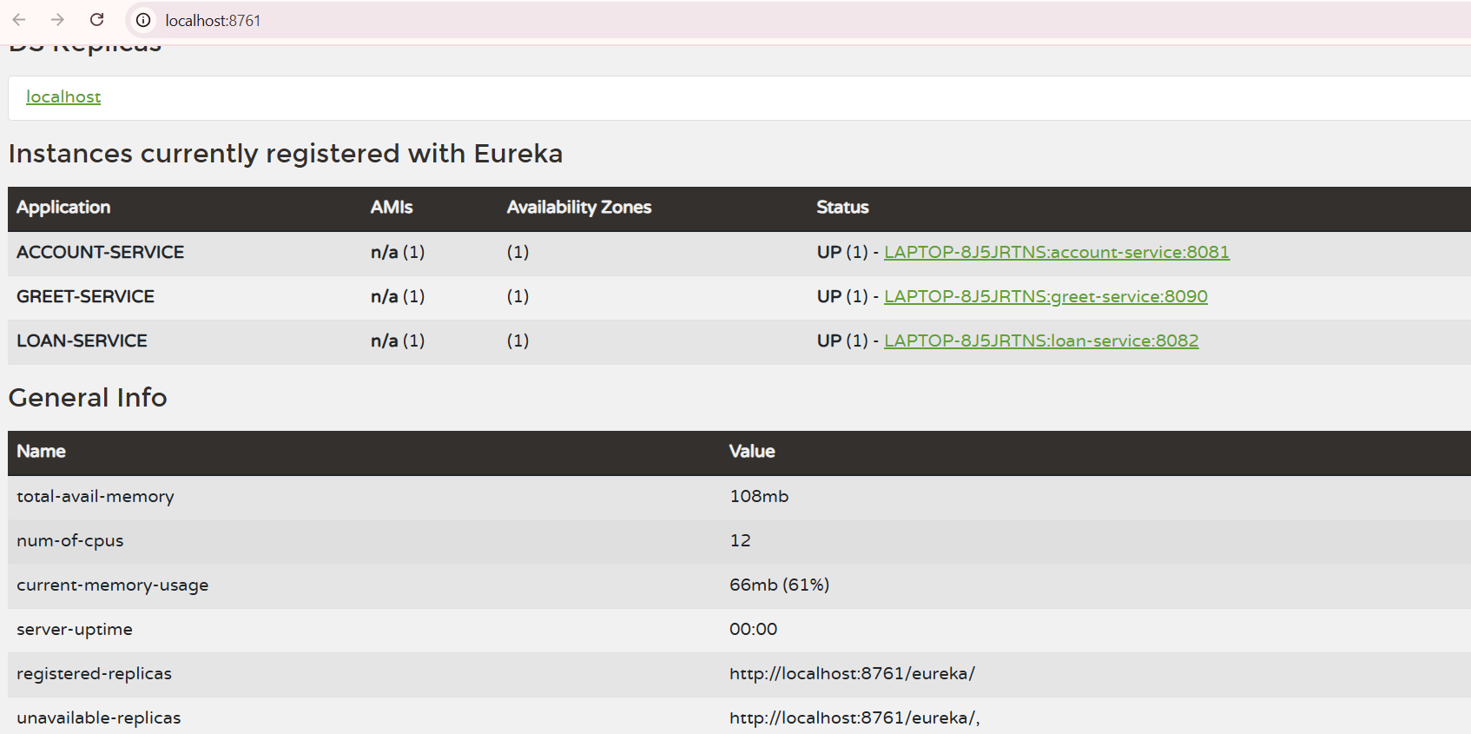

**APIGateway**

package com.example.api_gateway;

import org.springframework.boot.SpringApplication;

import org.springframework.boot.autoconfigure.SpringBootApplication;

@SpringBootApplication

public class ApiGatewayApplication {

public static void main(String[] args) {

SpringApplication.run(ApiGatewayApplication.class, args);

}

}

**Properties**

spring.application.name=api-gateway

server.port=9090

eureka.client.register-with-eureka=true

eureka.client.fetch-registry=true

spring.cloud.gateway.discovery.locator.enabled=true

spring.cloud.gateway.discovery.locator.lower-case-service-id=true

